Name : K.AravindRoyal

Trainer Name:- Harshee pithoda

Course Name:-python for machine learning

Date :-01/06/22

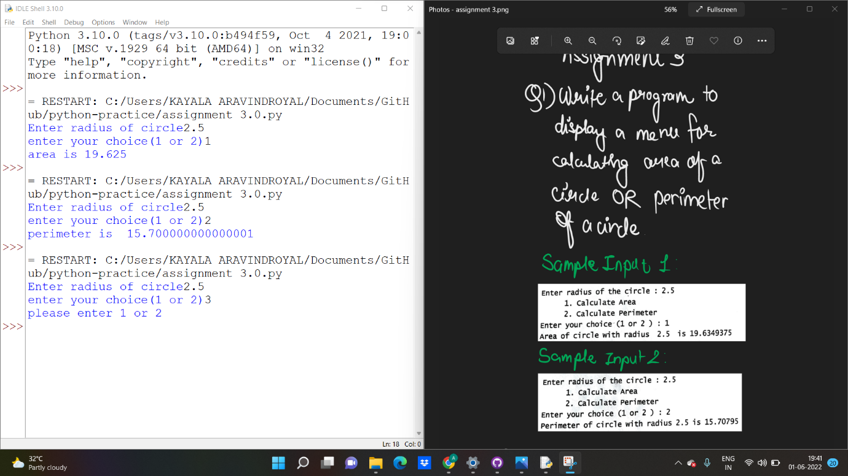

a=float(input('Enter radius of circle'))

b=int(input('enter your choice(1 or 2)'))

if b==1:

print('area is',(22/7)\*a\*a)

elif b==2:

print('perimeter is ',2\*(22/7)\*a)

else:

print('please enter 1 or 2')

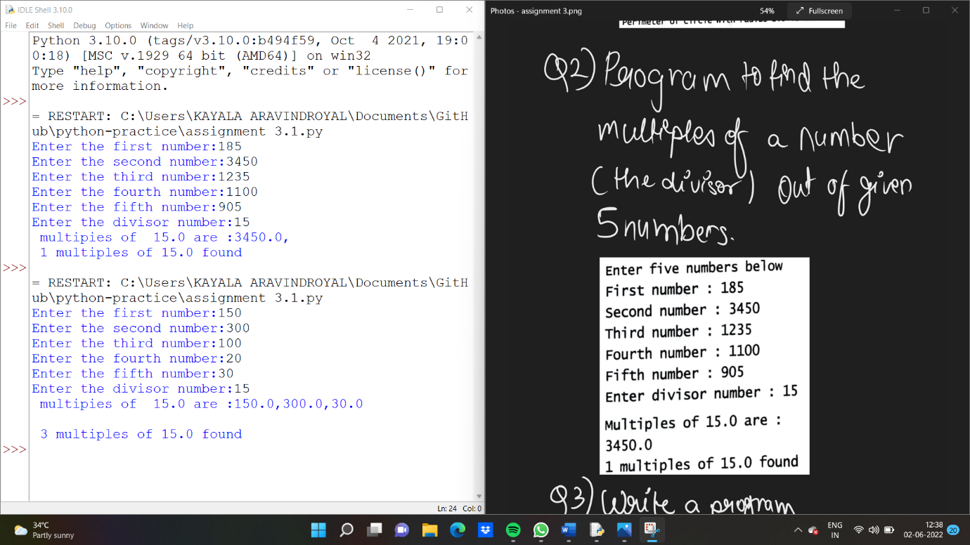

a=float(input('Enter the first number:'))

b=float(input('Enter the second number:'))

c=float(input('Enter the third number:'))

d=float(input('Enter the fourth number:'))

e=float(input('Enter the fifth number:'))

f=float(input('Enter the divisor number:'))

sum=0

g=a%f

h=b%f

i=c%f

j=d%f

k=e%f

print(' multipies of ',f ,'are :',end='')

if g==0:

print(a,end=',')

sum=sum+1

if h==0:

print(b,end=',')

sum=sum+1

if i==0:

print(c,end=',')

sum=sum+1

if j==0:

print(d,end=',')

sum=sum+1

if k==0:

print(e)

sum=sum+1

print('\n',sum,'multiples of',f,'found')

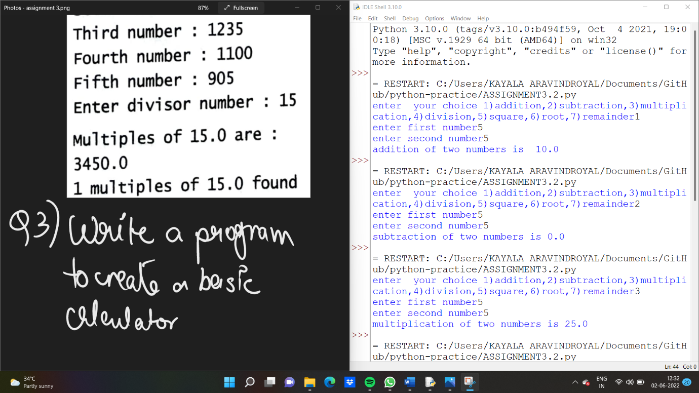

a=int(input('enter your choice 1)addition,2)subtraction,3)multiplication,4)division,5)square,6)root,7)remainder'))

if a==1:

b=float(input('enter first number'))

c=float(input('enter second number'))

print('addition of two numbers is ',b+c)

elif a==2:

b=float(input('enter first number'))

c=float(input('enter second number'))

print('subtraction of two numbers is',b-c)

elif a==3:

b=float(input('enter first number'))

c=float(input('enter second number'))

print('multiplication of two numbers is',b\*c)

elif a==4:

b=float(input('enter first number'))

c=float(input('enter second number'))

print('division of two numbers is',b/c)

elif a==5:

b=float(input('enter first number'))

c=float(input('enter second number'))

print('square of two numbers is',b\*\*2)

elif a==6:

b=float(input('enter first number'))

print('Root of the numbers is',b\*\*(0.5))

elif a==7:

b=float(input('enter first number'))

c=float(input('enter second number'))

print('remainder of two numbers is',b%c)

else:

print('plase check your option')